**Create table employees in External**

CREATE EXTERNAL TABLE employees(Name STRING, Job_Titles STRING, Department STRING, Full_Part_Time CHAR(1), Salary_or_Hourly STRING, Typical_Hours INT ,Annual_Salary STRING ,Hourly_Rate STRING) ROW FORMAT SERDE 'org.apache.hadoop.hive.serde2.OpenCSVSerde'

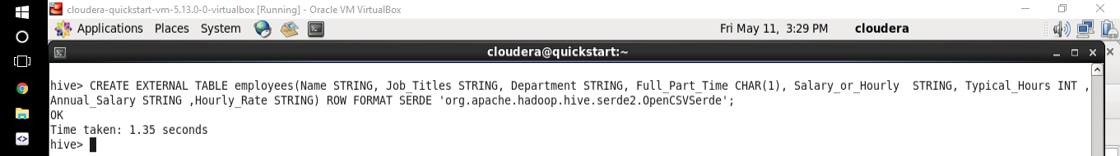

**Load data into the table**

LOAD DATA LOCAL INPATH '/home/cloudera/cs523/Current_Employee_Names__Salaries__and_Position_Titles.csv' OVERWRITE INTO TABLE employees;

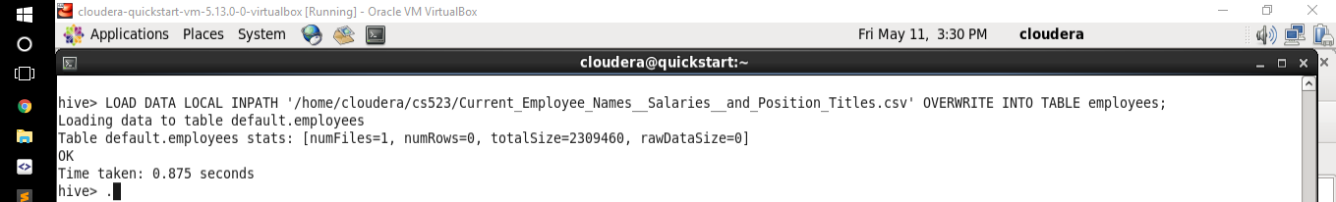

***1/ Show each Department with max salary of it***

**Query:**

SELECT Department, printf('$%f',MAX(cast(substr(Annual_Salary,2) as DOUBLE))) FROM employees WHERE Salary_or_Hourly =='Salary' GROUP BY Department;

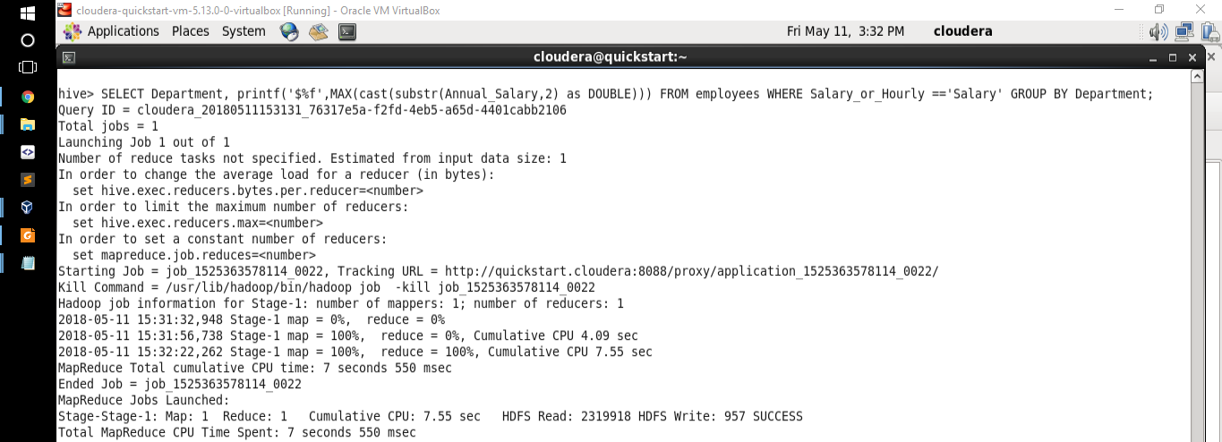

**Result**

ADMIN HEARNG $156420.000000

ANIMAL CONTRL $130008.000000

AVIATION $300000.000000

BOARD OF ELECTION $133740.000000

BOARD OF ETHICS $135672.000000

BUDGET & MGMT $169992.000000

BUILDINGS $157092.000000

BUSINESS AFFAIRS $157092.000000

CITY CLERK $133545.000000

CITY COUNCIL $168264.000000

COMMUNITY DEVELOPMENT $175020.000000

COPA $161856.000000

CULTURAL AFFAIRS $155040.000000

DISABILITIES $138420.000000

DoIT $154992.000000

FAMILY & SUPPORT $175002.000000

FINANCE $165000.000000

FIRE $202728.000000

GENERAL SERVICES $163896.000000

HEALTH $177000.000000

HUMAN RELATIONS $125004.000000

HUMAN RESOURCES $151572.000000

INSPECTOR GEN $161856.000000

LAW $173664.000000

LICENSE APPL COMM $84420.000000

MAYOR'S OFFICE $216210.000000

OEMC $167796.000000

POLICE $260004.000000

POLICE BOARD $105792.000000

PROCUREMENT $167220.000000

PUBLIC LIBRARY $167004.000000

STREETS & SAN $154428.000000

TRANSPORTN $169500.000000

TREASURER $150000.000000

WATER MGMNT $169512.000000

Time taken: 71.63 seconds, Fetched: 35 row(s)

***2/ Show list of employees have name start with ‘A’, has part-time job and Typical Hours >=20***

**Query:**

SELECT Name, Job_Titles, Department, Full_Part_Time, Salary_or_Hourly, Typical_Hours FROM employees Where Name LIKE CONCAT('A','%') AND Full_Part_Time LIKE 'P' AND Typical_Hours >=20;

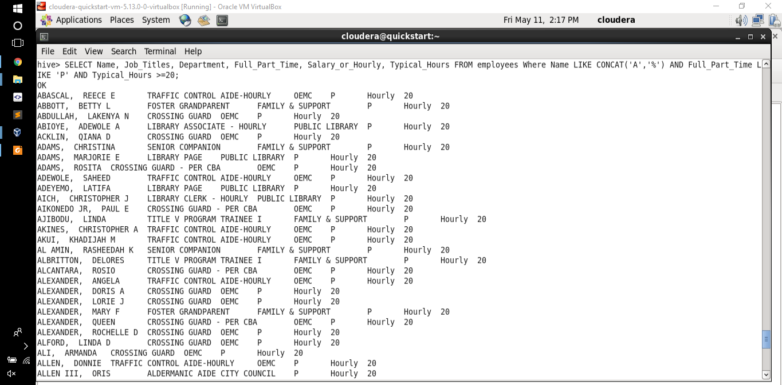

**Result:**

ABASCAL, REECE E TRAFFIC CONTROL AIDE-HOURLY OEMC P Hourly 20

ABBOTT, BETTY L FOSTER GRANDPARENT FAMILY & SUPPORT P Hourly 20

ABDULLAH, LAKENYA N CROSSING GUARD OEMC P Hourly 20

ABIOYE, ADEWOLE A LIBRARY ASSOCIATE - HOURLY PUBLIC LIBRARY P Hourly 20

ACKLIN, QIANA D CROSSING GUARD OEMC P Hourly 20

ADAMS, CHRISTINA SENIOR COMPANION FAMILY & SUPPORT P Hourly 20

ADAMS, MARJORIE E LIBRARY PAGE PUBLIC LIBRARY P Hourly 20

ADAMS, ROSITA CROSSING GUARD - PER CBA OEMC P Hourly 20

ADEWOLE, SAHEED TRAFFIC CONTROL AIDE-HOURLY OEMC P Hourly 20

ADEYEMO, LATIFA LIBRARY PAGE PUBLIC LIBRARY P Hourly 20

AICH, CHRISTOPHER J LIBRARY CLERK - HOURLY PUBLIC LIBRARY P Hourly 20

AIKONEDO JR, PAUL E CROSSING GUARD - PER CBA OEMC P Hourly 20

AJIBODU, LINDA TITLE V PROGRAM TRAINEE I FAMILY & SUPPORT P Hourly 20

AKINES, CHRISTOPHER A TRAFFIC CONTROL AIDE-HOURLY OEMC P Hourly 20

AKUI, KHADIJAH M TRAFFIC CONTROL AIDE-HOURLY OEMC P Hourly 20

AL AMIN, RASHEEDAH K SENIOR COMPANION FAMILY & SUPPORT P Hourly 20

ALBRITTON, DELORES TITLE V PROGRAM TRAINEE I FAMILY & SUPPORT P Hourly 20

ALCANTARA, ROSIO CROSSING GUARD - PER CBA OEMC P Hourly 20

ALEXANDER, ANGELA TRAFFIC CONTROL AIDE-HOURLY OEMC P Hourly 20

ALEXANDER, DORIS A CROSSING GUARD OEMC P Hourly 20

ALEXANDER, LORIE J CROSSING GUARD OEMC P Hourly 20

ALEXANDER, MARY F FOSTER GRANDPARENT FAMILY & SUPPORT P Hourly 20

ALEXANDER, QUEEN CROSSING GUARD - PER CBA OEMC P Hourly 20

ALEXANDER, ROCHELLE D CROSSING GUARD OEMC P Hourly 20

ALFORD, LINDA D CROSSING GUARD OEMC P Hourly 20

ALI, ARMANDA CROSSING GUARD OEMC P Hourly 20

ALLEN, DONNIE TRAFFIC CONTROL AIDE-HOURLY OEMC P Hourly 20

ALLEN III, ORIS ALDERMANIC AIDE CITY COUNCIL P Hourly 20

ALLEN, MARIE CROSSING GUARD OEMC P Hourly 20

ALLEN, MYRA B CROSSING GUARD OEMC P Hourly 20

ALLEN, NAJJA T LIBRARY ASSOCIATE - HOURLY PUBLIC LIBRARY P Hourly 20

ALLEN, SAHID J TRAFFIC CONTROL AIDE-HOURLY OEMC P Hourly 20

ALLEN, TANYALE M CROSSING GUARD - PER CBA OEMC P Hourly 20

ALONZO, JESSICA M LIBRARY CLERK - HOURLY PUBLIC LIBRARY P Hourly 20

ALSTON, NICOLE T TRAFFIC CONTROL AIDE-HOURLY OEMC P Hourly 20

AMADOR, BIANCA LEGISLATIVE AIDE CITY COUNCIL P Hourly 20

ANDERSON, BRANDON W LIBRARY PAGE PUBLIC LIBRARY P Hourly 20

ANDERSON, BRONNEKA G CROSSING GUARD - PER CBA OEMC P Hourly 20

ANDERSON, DIANE G CROSSING GUARD OEMC P Hourly 20

ANDERSON, ELIZER TRAFFIC CONTROL AIDE-HOURLY OEMC P Hourly 20

ANDERSON, OLIVER TRAFFIC CONTROL AIDE-HOURLY OEMC P Hourly 20

ANDERSON, ROSLYN FOSTER GRANDPARENT FAMILY & SUPPORT P Hourly 20

ANDERSON, SUSAN E CROSSING GUARD - PER CBA OEMC P Hourly 20

ANDERSON, TAMMY T CROSSING GUARD - PER CBA OEMC P Hourly 20

ANDERSON, VERONICA M CROSSING GUARD - PER CBA OEMC P Hourly 20

ANDERSON, YVETTE M CROSSING GUARD OEMC P Hourly 20

ANDREWS, RISHAUNDA M LIBRARY CLERK - HOURLY PUBLIC LIBRARY P Hourly 20

ANTHONY, DANIELLE P TRAFFIC CONTROL AIDE-HOURLY OEMC P Hourly 20

APEL, JOHN F AVIATION SECURITY OFFICER - HOURLY AVIATION P Hourly 20

ARCADIO, ODALIS ALDERMANIC AIDE CITY COUNCIL P Hourly 35

ARCHIE, KEWAIN Q TRAFFIC CONTROL AIDE-HOURLY OEMC P Hourly 20

ARNOLD, ANDREA CROSSING GUARD OEMC P Hourly 20

ARNOLD, ANTOINETTE TRAFFIC CONTROL AIDE-HOURLY OEMC P Hourly 20

ARNOLD, PEARLIE CROSSING GUARD OEMC P Hourly 20

ASHFORD, MICHELLE D CROSSING GUARD OEMC P Hourly 20

ASKEW, ALISON L CROSSING GUARD OEMC P Hourly 20

ATTERBERRY JR, CORTEZ CROSSING GUARD - PER CBA OEMC P Hourly 20

AUGUSTAVE, LAFONTANT J FOSTER GRANDPARENT FAMILY & SUPPORT P Hourly 20

AUSTIN, TIARA N CROSSING GUARD - PER CBA OEMC P Hourly 20

AVALOS, WENDOLLYN LIBRARY CLERK - HOURLY PUBLIC LIBRARY P Hourly 20

AVILA, ELENA CROSSING GUARD OEMC P Hourly 20

AVILES, ANAMARIA CROSSING GUARD OEMC P Hourly 20

Time taken: 0.117 seconds, Fetched: 62 row(s)

***3/ Show total salary of each department***

**Query:**

SELECT Department, MAX(salary) AS salary FROM(

SELECT Department, MAX(CAST(SUBSTR(Annual_Salary,2) AS DOUBLE)) AS salary

FROM employees GROUP BY Department

UNION ALL

SELECT Department, MAX(CAST(SUBSTR(Hourly_Rate,2) AS float)*Typical_Hours *52) AS salary

FROM employees GROUP BY Department

) max

GROUP BY Department

ORDER BY salary DESC;

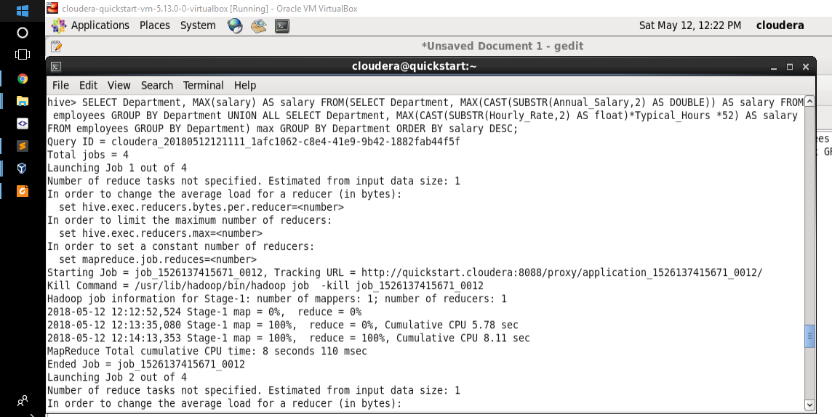

**Result:**

AVIATION 300000.0

POLICE 260004.0

MAYOR'S OFFICE 216210.0

FIRE 202728.0

HEALTH 198380.0

COMMUNITY DEVELOPMENT 175020.0

FAMILY & SUPPORT 175002.0

LAW 173664.0

BUDGET & MGMT 169992.0

WATER MGMNT 169512.0

TRANSPORTN 169500.0

CITY COUNCIL 168264.0

OEMC 167796.0

PROCUREMENT 167220.0

PUBLIC LIBRARY 167004.0

FINANCE 165000.0

GENERAL SERVICES 163896.0

COPA 161856.0

INSPECTOR GEN 161856.0

BUILDINGS 157092.0

BUSINESS AFFAIRS 157092.0

ADMIN HEARNG 156420.0

CULTURAL AFFAIRS 155040.0

DoIT 154992.0

STREETS & SAN 154428.0

HUMAN RESOURCES 151572.0

TREASURER 150000.0

DISABILITIES 138420.0

BOARD OF ETHICS 135672.0

BOARD OF ELECTION 133740.0

CITY CLERK 133545.0

ANIMAL CONTRL 130008.0

HUMAN RELATIONS 125004.0

POLICE BOARD 105792.0

LICENSE APPL COMM 84420.0

Department NULL

Time taken: 257.388 seconds, Fetched: 36 row(s)